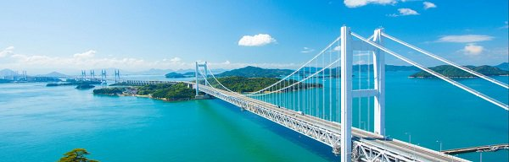**Akashi Kaikyō Bridge**

The Akashi Kaikyō Bridge (明石海峡大橋 Akashi Kaikyō Ōhashi) is a suspension bridge, which links the city of Kobe on the Japanese mainland of Honshu to Iwaya on Awaji Island. It crosses the busy Akashi Strait (Akashi Kaikyō in Japanese) as part of the Honshu–Shikoku Highway. It was completed in 1998, and has the longest central span of any suspension bridge in the world, at 1,991 metres (6,532 ft; 1.237 mi). It is one of the key links of the Honshū–Shikoku Bridge Project, which created three routes across the Inland Sea.

**History**

Before the Akashi Kaikyō Bridge was built, ferries carried passengers across the Akashi Strait in Japan. This dangerous waterway often experiences severe storms, and in 1955 two ferries sank in the strait during a storm, killing 168 people. The ensuing shock and public outrage convinced the Japanese government to develop plans for a bridge to cross the strait. The original plan called for a mixed railway-road bridge, but when construction on the bridge began in April 1988, the construction was restricted to road only, with six lanes. Actual construction did not begin until May 1988 and involved more than 100 contractors. The bridge was opened for traffic on April 5, 1998 in a ceremony officiated by the Crown Prince Naruhito and his spouse Crown Princess Masako of Japan along with Construction Minister Tsutomu Kawara.

It was completed in 2010 and opened in 2011. Employing 10,000 people, construction took four years and cost about $8.5 billion. The Danyang–Kunshan Grand Bridge currently holds the Guinness World Record for the longest bridge in the world in any category as of June 2011.